**Aim: Project Proposal and Requirement Gathering**

**Topic: MyHome - IoT Based Smart Home Automation System**

**Objective:**

The main reason for choosing this project is to make life easier of human beings. As we all live a busy lifestyle some may feel turning off the lights, fan, etc., before going out is a time-consuming process. But no so long as this technology helps us in monitoring everything single handily by monitoring it with the help of our phone(s). As you become aged, simple tasks can become difficult. With features like voice command, home automation gives freedom and independence to the elderly. Additionally, the idea of home automation system will improve the normal living status at houses.

**Advantages:**

1. **Safety:** User will be notified when any fire or gas leakage is there.
2. **Real time monitoring:** User will get to know electricity usage statistics, water tank level, plant moisture level.
3. **Centralized system:** User will get all features of home automation at one platform.
4. **Saves Time:** Everyone is living in busy environment, user don’t even have to worry about the home.
5. **Ease for Disabled & Senior Citizens:** For Elderly & disabled people, simple tasks can become difficult. With features like voice command, home automation gives freedom and independence to the elderly.
6. **Monitor from anywhere:** User can monitor their home from anywhere they just have to login.

**Disadvantages:**

1. **Dependency on Internet:** The system requires active strong internet connection (24×7)
2. **Dependency on power supply:** The system requires power supply (24×7)
3. **Electronic Circuit Failure:** Electronic Kit and Circuit may fail in future can cause malfunctioning to the system, short-circuit to the system.

**What Is Smart Home Automation?**

Smart Home automation is the automatic control of electronic devices in your home. These devices are connected to the Internet, which allows them to be controlled remotely. With home automation, devices can trigger one another so you don’t have to control them manually via an app or voice assistant. For example, you can put your lights on schedules so that they turn off when you normally go to sleep, or you can have your thermostat turn the A/C up about an hour before you return to work so you don’t have to return to a stuffy house. Home automation makes life more convenient and can even save you money on heating, cooling and electricity bills. Home automation can also lead to greater safety with Internet of Things devices like security cameras and systems.

**PROPOSED SYSTEM:**

1. **Electrical port switching (on/off):** User can switch ON the electrical ports and switch OFF the electrical ports. There will be total 4 ports.
2. **Automatic on/off the electrical ports:** User will select Days, Start Time, Stop Time for the particular electrical port. At selected days & time the electrical port will automatically turned ON & turned OFF.
3. **Electricity consumption monitoring:** User will get the real time consumption information in the mobile. User will get the information such as energy consumption, power consumption, current consumption, bill (in rs). User can see the graph of the consumption.
4. **Water tank measuring:** User can see the current water level of the tank on mobile. User will be notified when the water tank will be full.
5. **Air quality monitoring:** User can see the current indoor Temperature, Humidity and the AQI (Air Quality Index) on mobile.
6. **Plant monitoring:** User can see the current moisture level of the plant on mobile. User will be notified when the plant needs water.
7. **Gas detection**: User will be notified when any gas leakage is detected.
8. **Fire detection:** User will be notified when any fire is detected.
9. **Google assistant:** User will voice command to the Google Assistant and particular action will be performed.
10. **Technical assistant bot:** User will ask command questions to the bot and bot will process it.
11. **Telegram Bot:** User will ask command questions to the telegram bot and telegram bot will process it.

**Technology Used:**

* ANDROID
* XML
* JAVA
* FIREBASE
* NODE JS

**Tools Used:**

* FIGMA
* ANDROID STUDIO

**Feasibility study:**

* Economic feasibility: This project was made at the price of INR 5000, hence it is economically feasible.
* Technical feasibility: The project is technically feasible as there is no problem in gathering the resources.
* Environmental feasibility: This project is environmentally friendly as this doesn't require any extra hardware resources which might create e-waste.
* Operational feasibility: This project is operationally feasible as it is very user friendly

**System Design:**

**Created using Figma:**

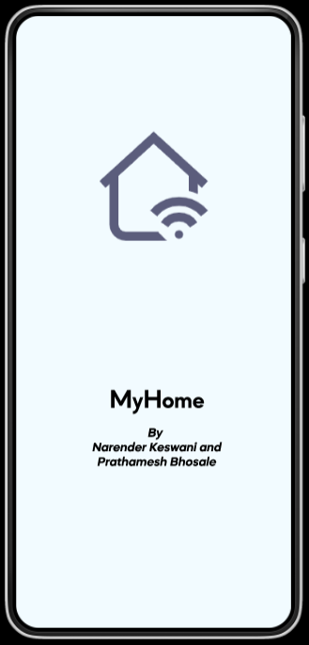

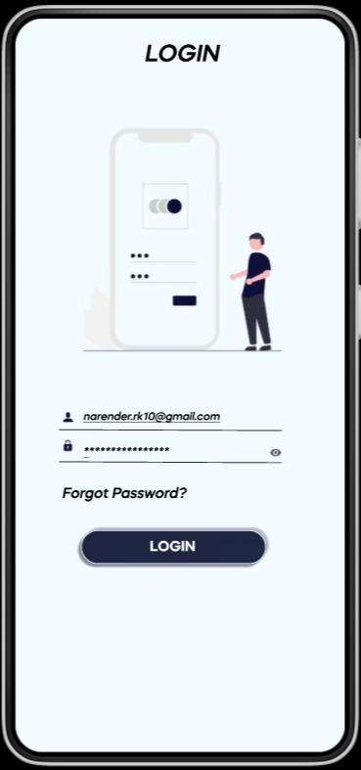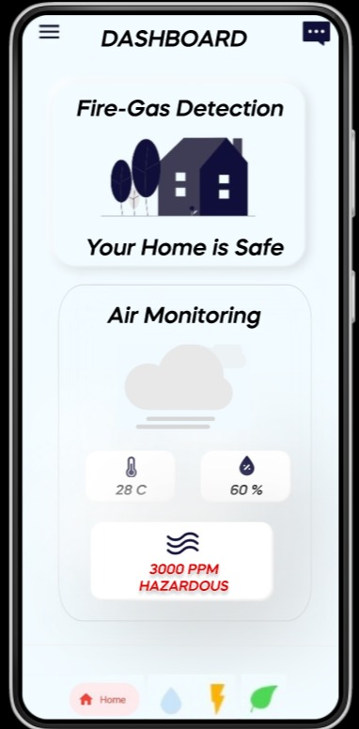

**UML Diagrams:**

1. **Entity Relationship Diagram (ERD):**

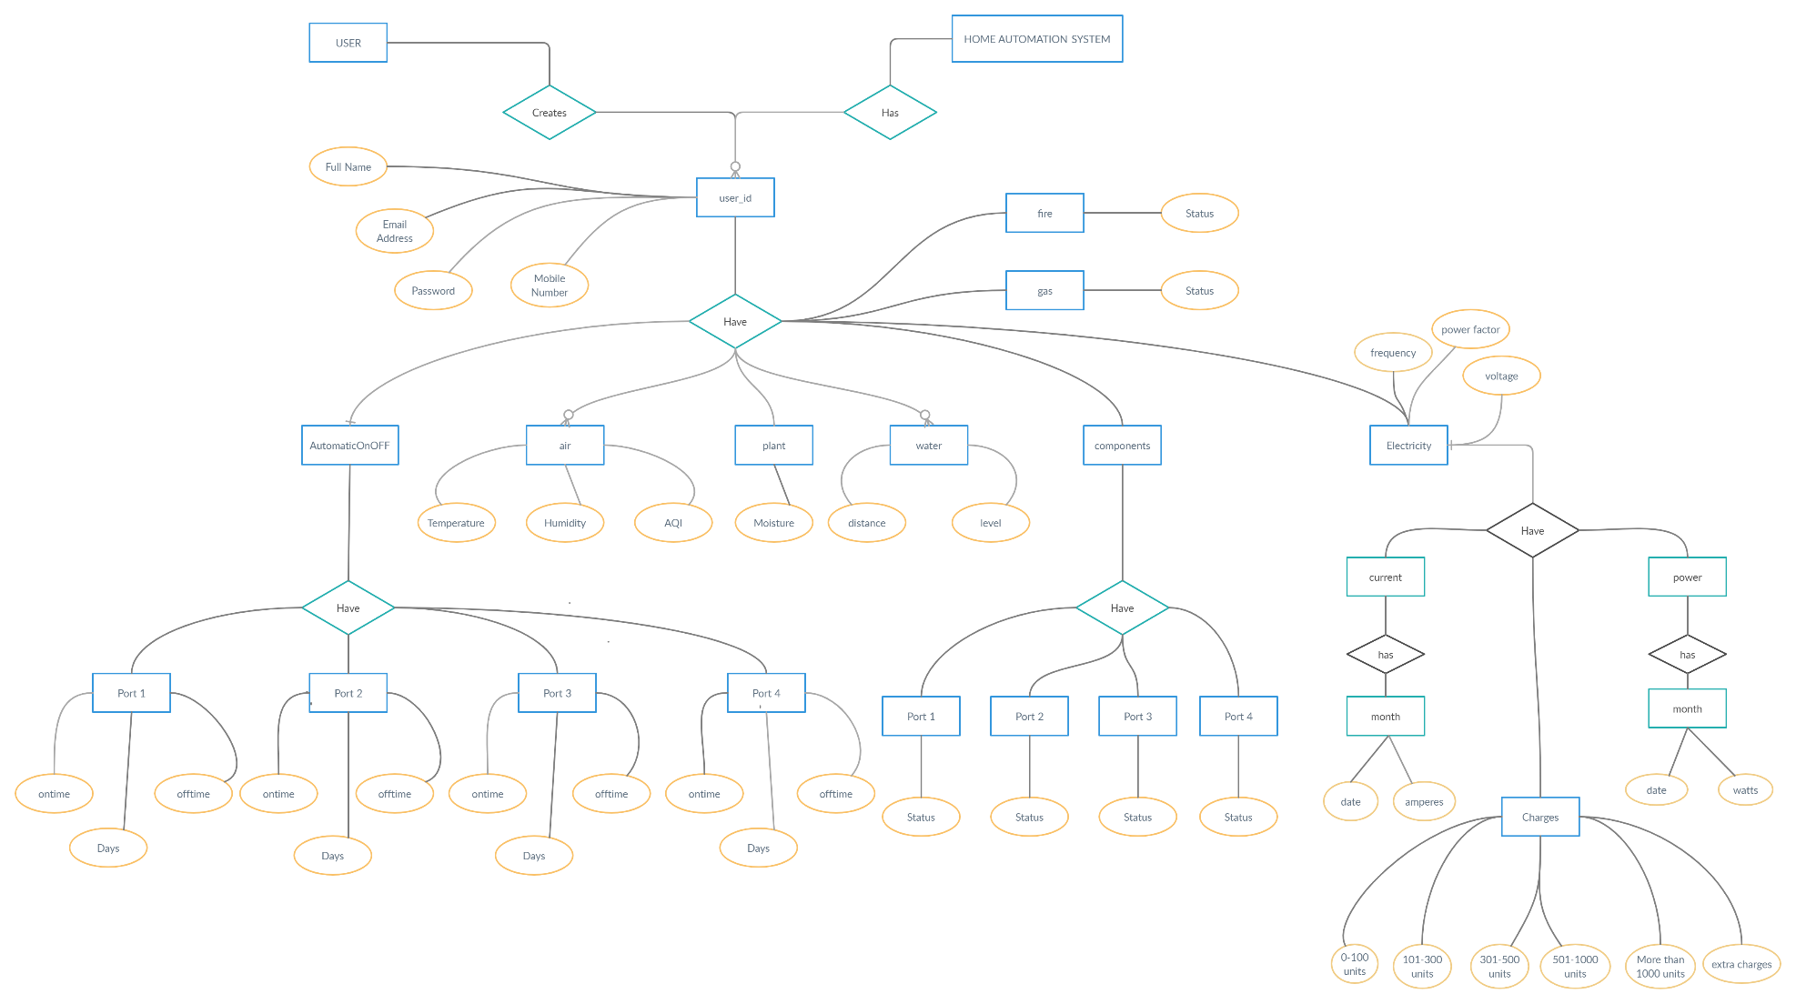

1. **Sequence Diagram:**

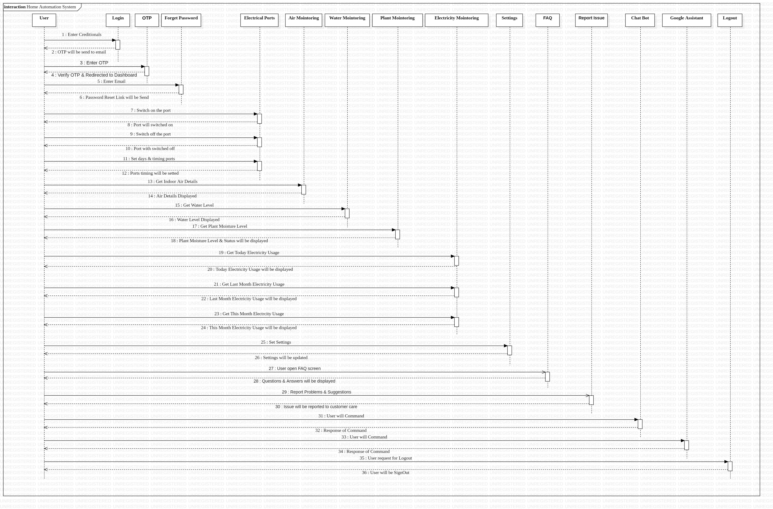

1. **State Diagram:**

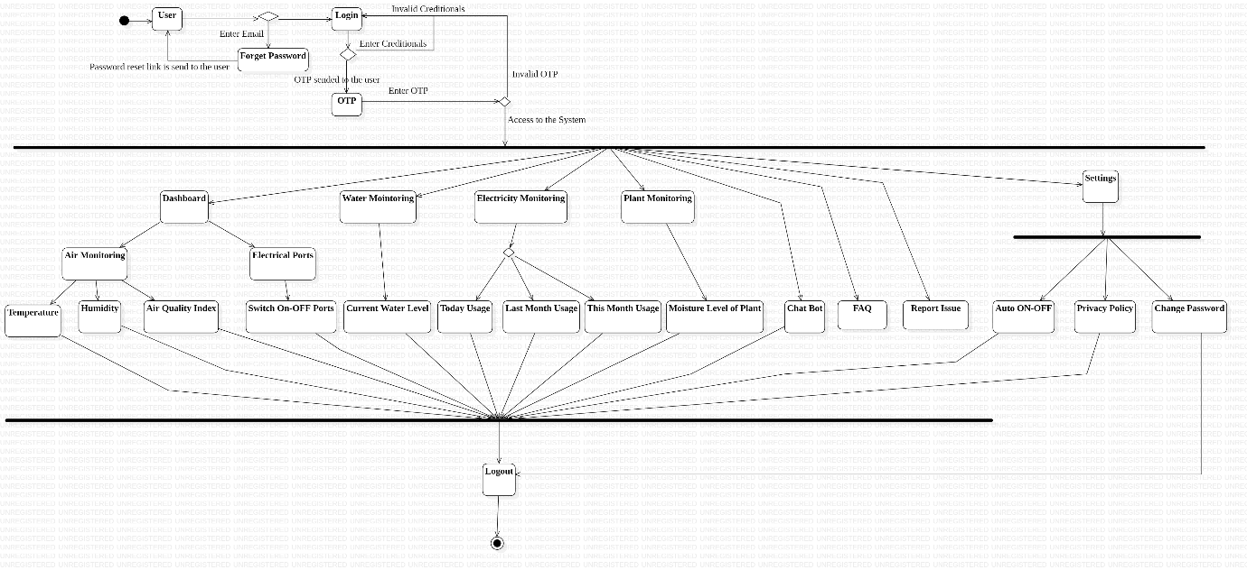

**CONCLUSION:**

Project Proposal and Requirement Gathering is done successfully by defining the proposed system with its advantages and describing tools and technologies used in development. Basic Flow of the proposed system is also described along with feasibility study. UML diagrams like Entity Relationship Diagram (ERD), sequence diagram and state diagrams are used to further describe the system flow of the proposed system.